BELLRINGER – TUESDAY 09/20

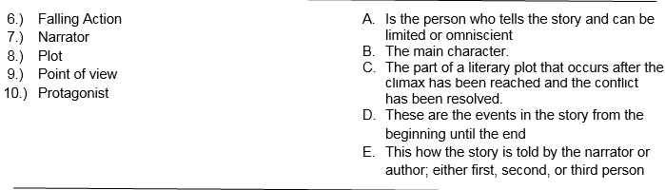

BELLRINGER – TUESDAY 09/20

BELLRINGER – TUESDAY 09/20

